
Copyright © 2012 DET Corp., Japan All Rights Reserved
ISSN 2186-2680
e-ISSN 2186-2656
www.ijce-journal.org
International Journal of Comprehensive Engineering
Part A, 2(2), 1-4, 1
Doi: 14270/IJCE2013.2.2.a1
Regular paper

Sequential Diagnosis for Rolling Bearing Using Fuzzy Neural Network
(Article Title:Times New Roman 14PT)
-- Subtitle as needed (Times New Roman 12PT)
Yifei Wang ^{1, #}, Toshio Yamamoto ² and John Lee ²
(Author name: Given name Family name, Times New Roman 11pt, Bold)
¹ School of Mechanical & Electrical Engineering, Beijing University of Chemical Technology,
Beijing, 100029, China
(Full Affiliation/Address: dept.name of organization, City, postal code, Country, Times New Roman 11pt)
² Full Affiliation/Address (list all distinct addresses in the same way)
# Corresponding author: abc@mail.edu; Tel.: +8-888-888-888; Fax: +8-888-888-889

Abstract: An abstract is required to be concise and factual (about 200 words). The abstract should state briefly the purpose of the research, the principal results and major conclusions. An abstract is often presented separately from the article, so it must be able to stand alone. References should be avoided. Also, non-standard or uncommon abbreviations should be avoided. (Times New Roman 11PT)
Keywords: Keyword, Keyword, Keyword. (3-6key words, Times New Roman 11PT)
Received: Jul. 10,2012 / Accepted: Nov. 1,2011 / Published: Nov. 3,2011
- Introduction (Heading 1)
All manuscripts must be in English. These guidelines include complete descriptions of the fonts, spacing, and related information for producing your proceedings manuscripts.
This template provides authors with most of the formatting specifications needed. All standard paper components have been specified for three reasons: (1) ease of use when formatting individual papers, (2) automatic compliance to the requirements, and (3) conformity of style. Margins, column widths, line spacing, and type styles are built-in; examples of the type styles are provided throughout this document. Please do not re-adjust these margins [A4 paper format, the printing area is 17 cm x 25.2 cm. The margins should be 2.0cm on each side of the paper (top, bottom, left, and right sides)]. Some components, such as multi-leveled equations, graphics, and tables are not prescribed, although the various table text styles are provided. The formatter will need to create these components, incorporating the applicable criteria that follow.
- Type Style and Fonts
Wherever Times New Roman is specified, Times or Times Roman may be used. Please embed symbol fonts, as well, for math, etc. Use 11 point Times New Roman for the abstract, keywords, text and heads of this paper. But Title (14PT), Subtitle (12PT), the labels and captions of Table and Figure (10PT) are particular cases.
- Maintaining the Integrity of the Specifications
The template is used to format your paper and style the text. All margins, column widths, line spaces, and text fonts are prescribed; please do not alter them. You may note peculiarities. For example, the head margin in this template measures proportionately more than is customary. This measurement and others are deliberate, using specifications that anticipate your paper as one part of the entire proceedings, and not as an independent document. Please do not revise any of the current designations.
- Prepare Your Paper Before Styling
Before you begin to format your paper, first write and save the content as a separate text file. Keep your text and graphic files separate until after the text has been formatted and styled. Do not use hard tabs, and limit use of hard returns to only one return at the end of a paragraph. Do not add any kind of pagination anywhere in the paper.
Finally, complete content and organizational editing before formatting. Please take note of the following items when proofreading spelling and grammar:
4.1 Abbreviations and Acronyms (Heading 2)
Define abbreviations and acronyms the first time they are used in the text, even after they have been defined in the abstract. Abbreviations such as IEEE, SI, MKS, CGS, sc, dc, and rms do not have to be defined. Do not use abbreviations in the title or heads unless they are unavoidable.
4.2 Units
Follow internationally accepted rules and conventions: use the international system of units (SI). If other quantities are mentioned, give their equivalent in SI.
4.3 Equations
The equations are an exception to the prescribed specifications of this template. You will need to determine whether or not your equation should be typed using either the Times New Roman or the Symbol font (please no other font). To create multileveled equations, it may be necessary to treat the equation as a graphic and insert it into the text after your paper is styled.
Number equations consecutively. Equation numbers, within parentheses, are to position flush right, as in Eq. (1), using a right tab stop. To make your equations more compact, you may use the solidus ( / ), the exp function. Italicize Roman symbols for quantities and variables, but not Greek symbols. Use a long dash rather than a hyphen for a minus sign. Punctuate equations with commas or periods when they are part of a sentence, as in
                                                                                   
Note that the equation is centered using a center tab stop. Be sure that the symbols in your equation have been defined before or immediately following the equation. Use “Eq.(1)”, not “(1)” or “equation (1)”.
- Using the Template
After the text edit has been completed, the paper is ready for the template.
  - Authors and Affiliations
The family name may be ambiguous (e.g., a double name), so please indicate this clearly. It is necessary to present the authors' affiliation addresses (where the actual work was done) below the names and indicate all affiliations with a lower-case superscript letter immediately after the author's name and in front of the appropriate address. Provide the full postal address of each affiliation, including the country name, and, if available, the e-mail address of each author.
  - Corresponding author
Clearly indicate the corresponding author to handle correspondence at all stages of refereeing and publication, also post-publication. Ensure that telephone and fax numbers (with country and area code) are provided in addition to the e-mail address and the complete postal address. Present/permanent address The address at which the author actually did the work must be retained as the main, affiliation address. Superscript Arabic numerals are used for such footnotes.
  - Figures and Tables

5.3.1 Positioning Figures and Tables(Heading 3)

Place figures and tables at the top and bottom of columns. Avoid placing them in the middle of columns. Large figures and tables may span across both columns. Figure captions should be below the figures; table heads should appear above the tables. Insert figures and tables after they are cited in the text. Use the abbreviation “Fig. 1”, even at the beginning of a sentence.

Table 1 Bearing information for verification (10pt)
Bearing NTN | Normal (N) | Roller race flaw (R) | Inner race flaw (I) | Outer race flaw (O)
Specification | N205E | N205E | NU205E | N205E
Our diameter | 52 mm | 52 mm | 52 mm | 52 mm
Inner diameter | 25 mm | 25 mm | 25 mm | 25 mm
Width | 15 mm | 15 mm | 15 mm | 15 mm
Roller number | 13 | 13 | 13 | 13
Contact angle | 0 | 0 | 0 | 0

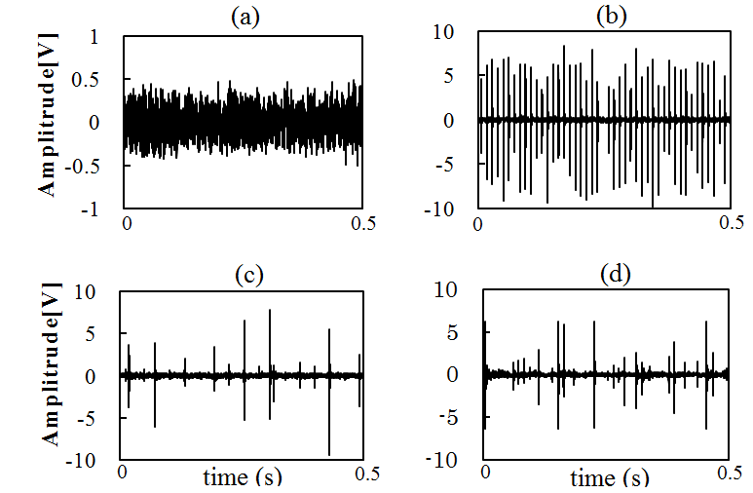
Fig. 1 Example of a ONE-COLUMN figure caption. (a) a descriptive label of the figure here. (b) a descriptive label of the figure . (c) a descriptive label of the figure here. (d) a descriptive label of the figure here. (10pt)
5.3.2 Footnotes
Footnotes should be used reasonable and sparingly. Number them consecutively throughout the article, using superscript Arabic numbers. About the table footnotes, indicate each footnote in a table with a superscript lowercase letter.
Acknowledgment
List here those individuals who provided help during the research (e.g., providing language help, writing assistance or proof reading the article, etc.).
References
List and number all bibliographical references in 11-point Times New Roman, single-spaced. When referenced in the text, enclose the citation number in square brackets, for example [1]. It is important to ensure that every reference cited in the text is also present in the reference list (and vice versa). Any references cited in the abstract must be given in full. Number the references (numbers in square brackets) in the list in the order in which they appear in the text.

- Christopher M. Bishop. Neural Networks for Pattern Recognition, Oxford Univesity Press, 1995. (In Book)
- H.Q Wang and P. Chen. Fuzzy Diagnosis Method for Rotating Machinery in Variable Rotating Speed, IEEE Sensors Journal, Vol. 11, No. 1, pp. 23-34, 2011. (Article in Journal)
- H.Q Wang, P. Chen and T. Mitoma. Sequential Diagnosis for Rolling Bearing Using Fuzzy Neural Network, Proceedings of International Conference on Advanced Intelligent Mechatronic, pp.56-61, IEEE xplore, July 2-5, 2008, Xi'an, China. (Article in Conference Proceeding)
- R. E. Haskell and C. T. Case, “Transient signal propagation in lossless isotropic plasmas,” USAF Cambridge Res. Lab., Cambridge, MA Rep. ARCRL-66-234 (II), vol. 2, 1994. (Report style)
- D. Kornack and P. Rakic. Cell Proliferation without Neurogenesis in Adult Primate Neocortex, Science, Dec. 2001, doi:10.1126/science.1065467. (Online)
- Transmission Systems for Communications, 3rd ed., Western Electric Co., Winston-Salem, NC, 1985, pp. 44–60. (Handbook style)
- J. K. Author. (year, month, day). Title (edition) [Type of medium]. Volume(issue). Available: http://www.(URL) (Basic Book/Monograph Online Sources)

